Daily:   
SQL Advance(5 Section daily): [Course: Advanced SQL for Data Engineering | Udemy Business](https://ibm-learning.udemy.com/course/advanced-sql-for-data-engineering/learn/lecture/38301898#overview)   
Python Advance(1 hour): <https://www.youtube.com/watch?v=GPVsHOlRBBI>  
ADF (4 Videos daily): <https://www.youtube.com/watch?v=8X4CGsIuxGg&list=PLMWaZteqtEaLTJffbbBzVOv9C0otal1FO&index=10>

Weekend: full day

Data Warehouse(SSIS): <https://www.youtube.com/watch?v=eNxbMwUGl1g>

Power BI: <https://www.youtube.com/watch?v=fGsl2kMzNPg>

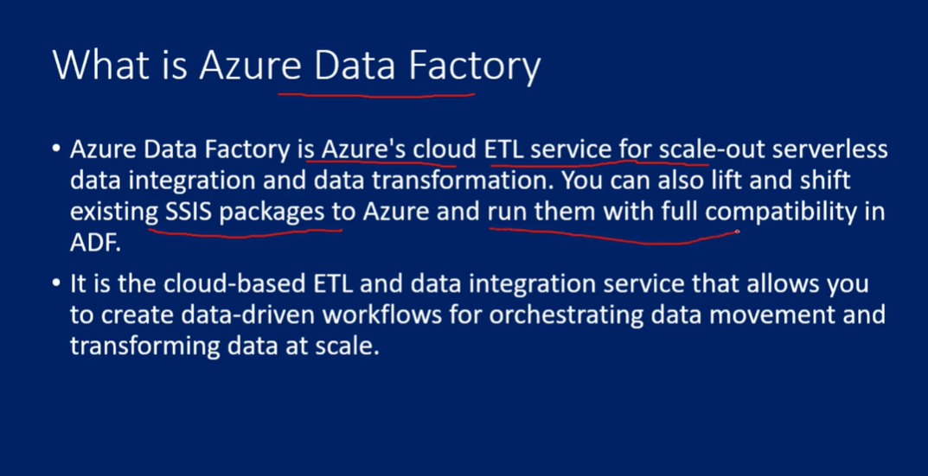

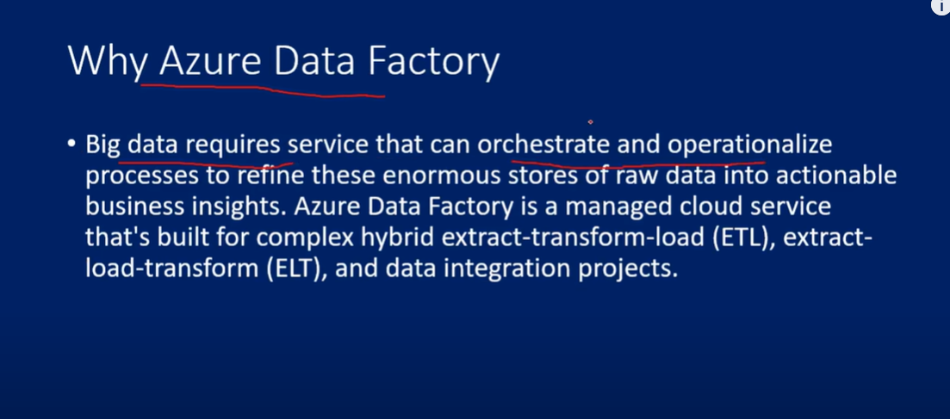

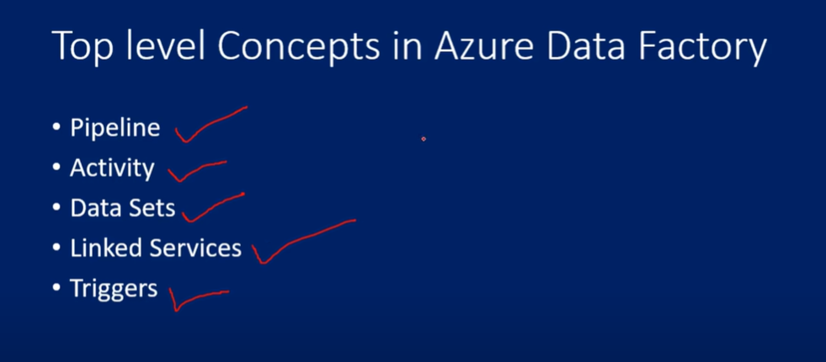

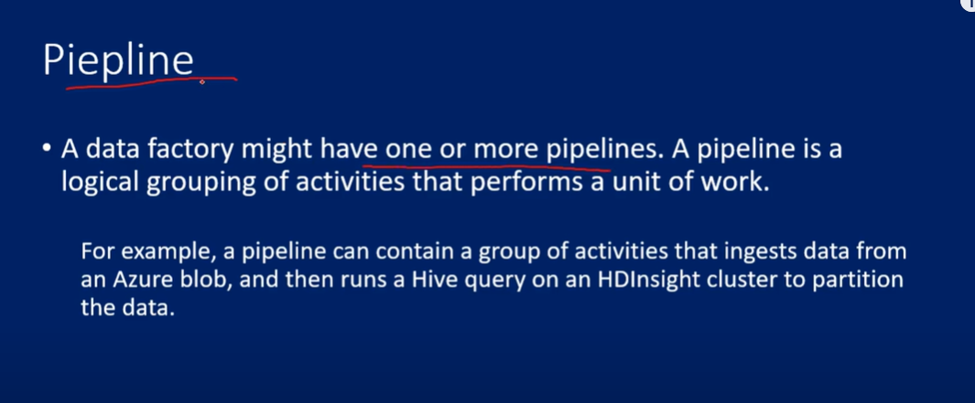

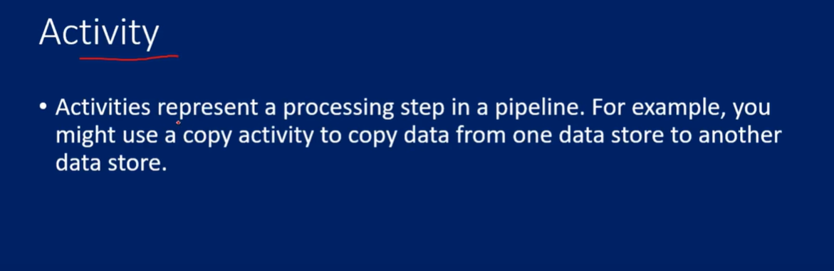

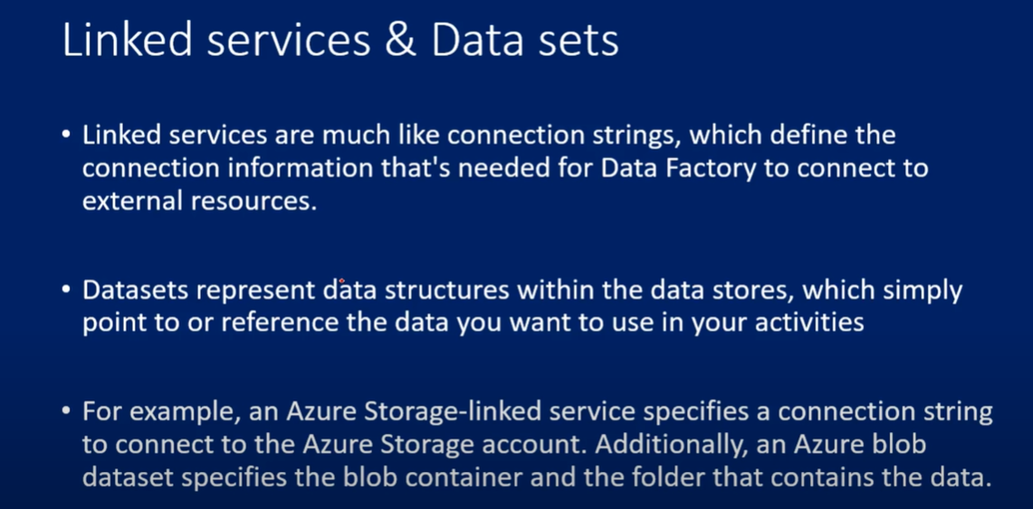

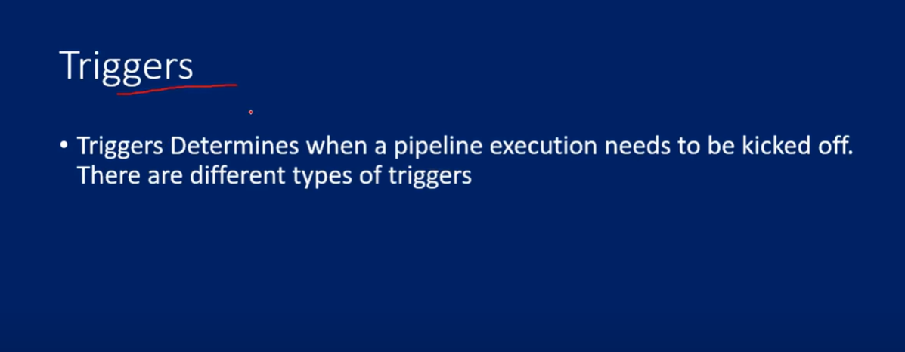

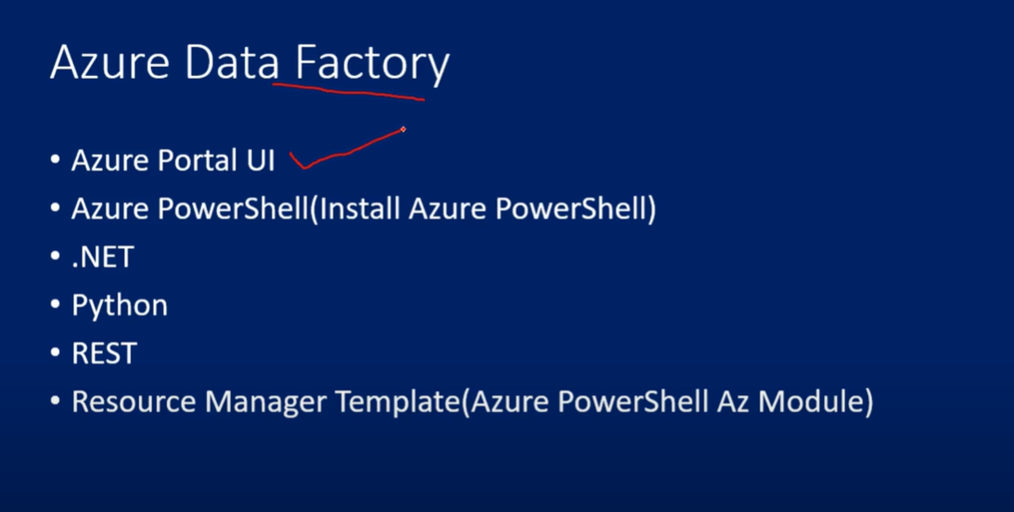

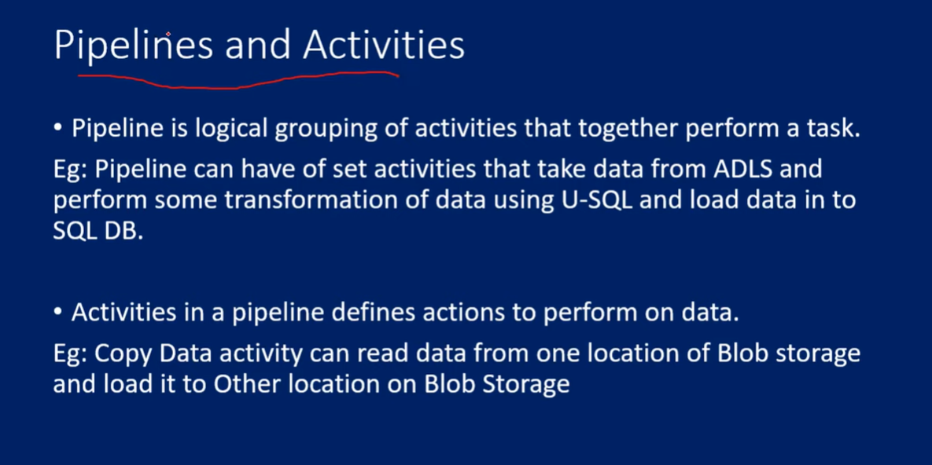

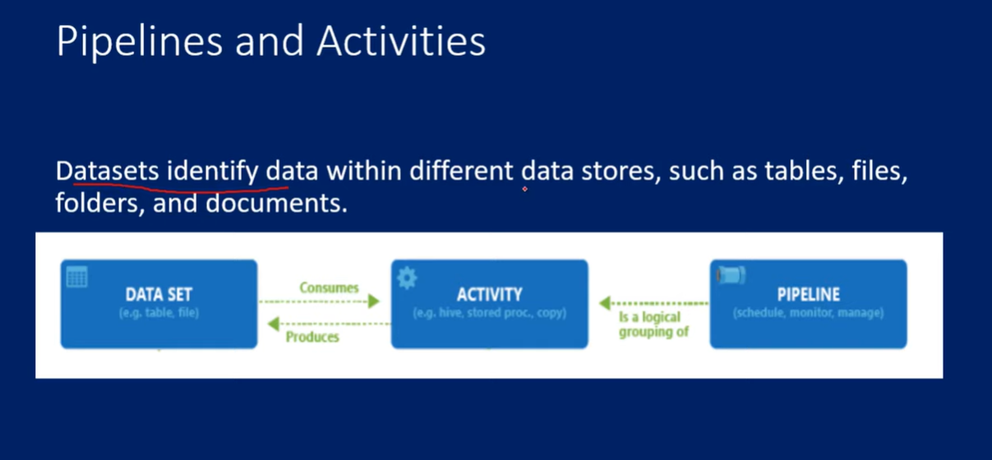

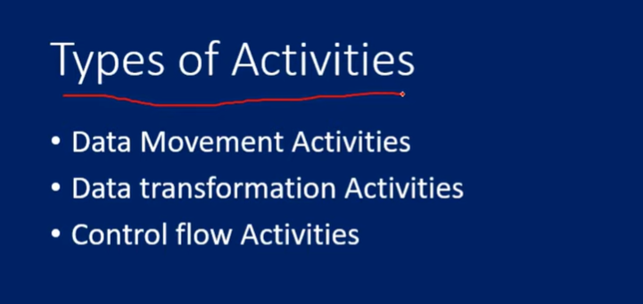

<https://learn.microsoft.com/en-us/azure/data-factory/concepts-pipelines-activities?tabs=data-factory>

<https://www.youtube.com/watch?v=_Ud_7wL24iM&list=PLMWaZteqtEaLTJffbbBzVOv9C0otal1FO&index=6>

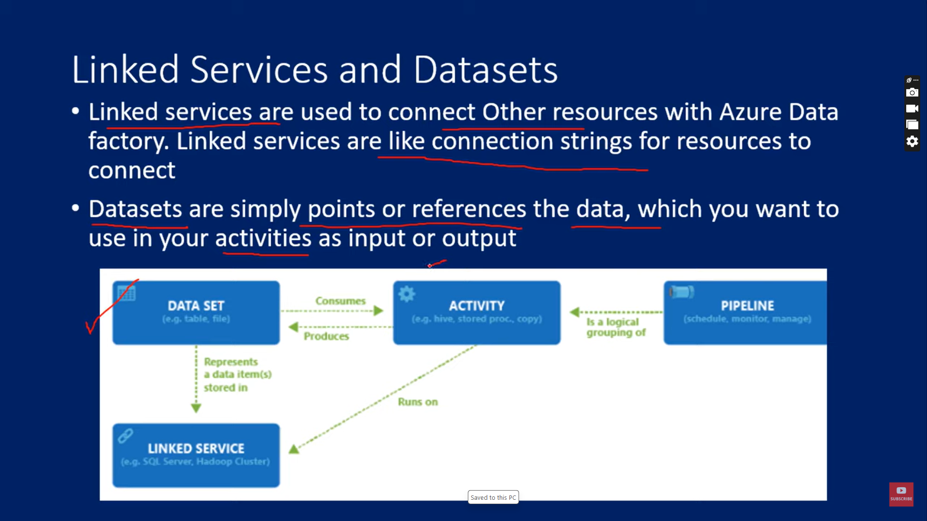

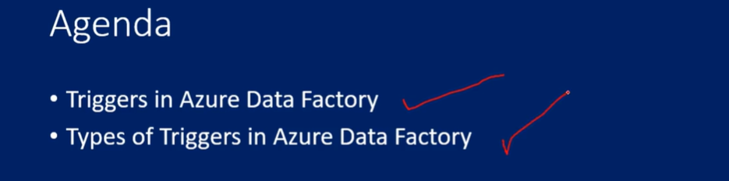  
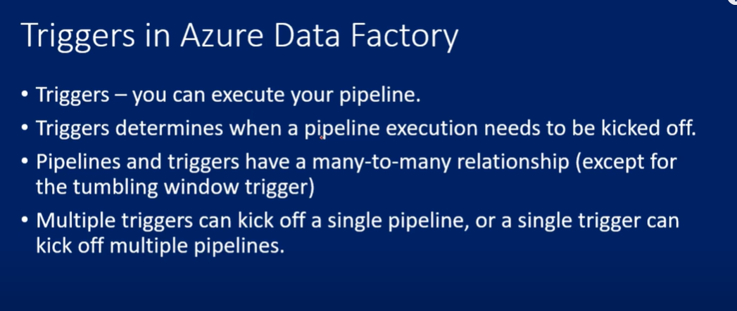

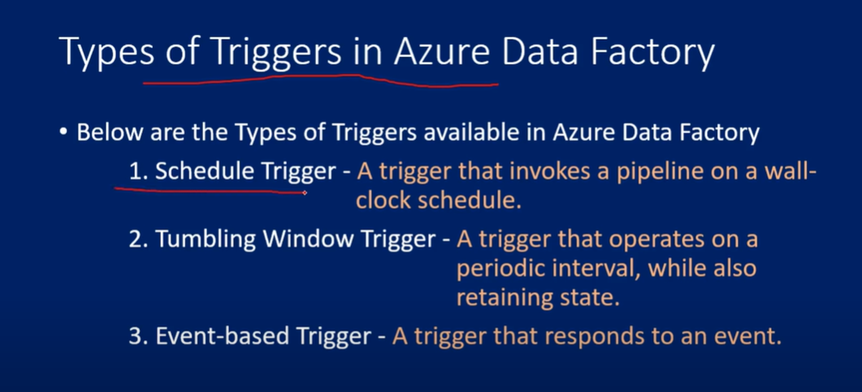 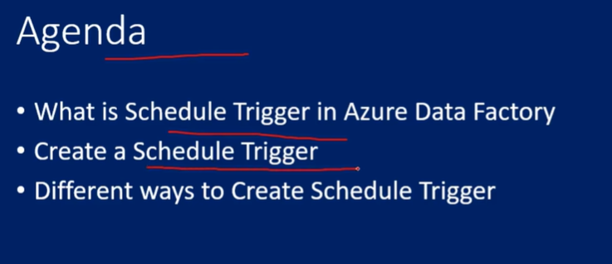 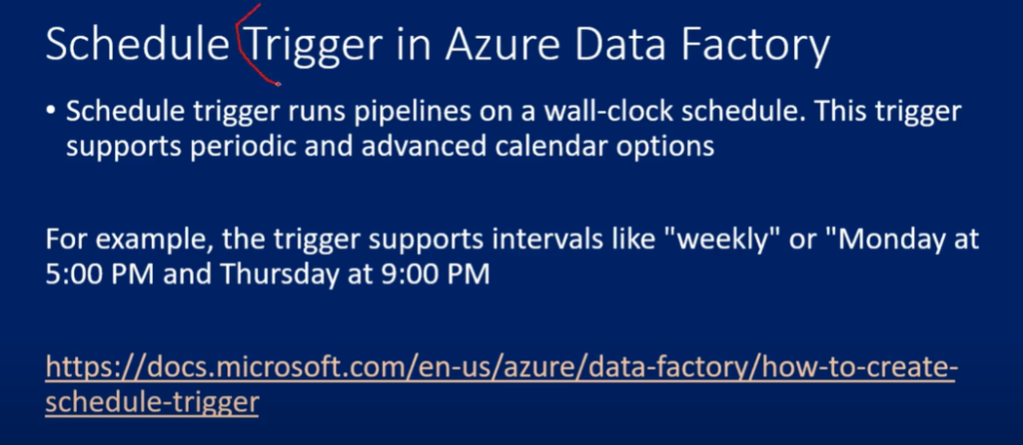 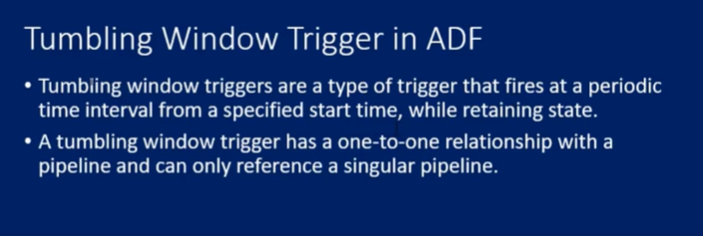

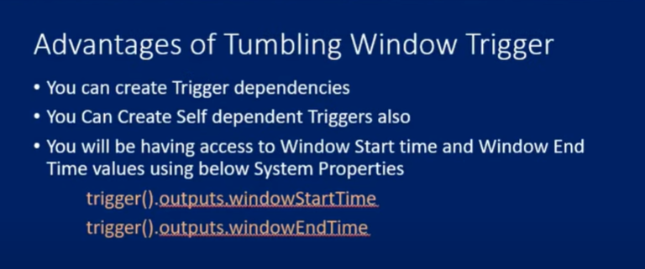

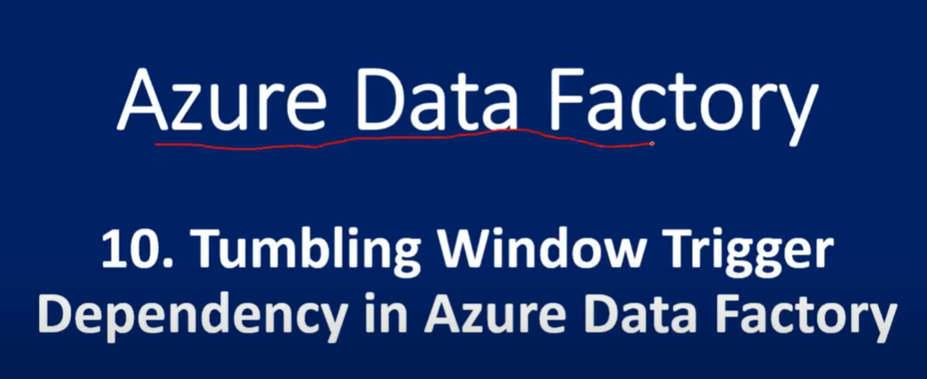

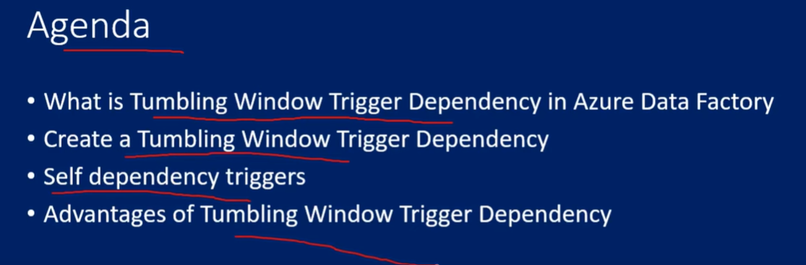

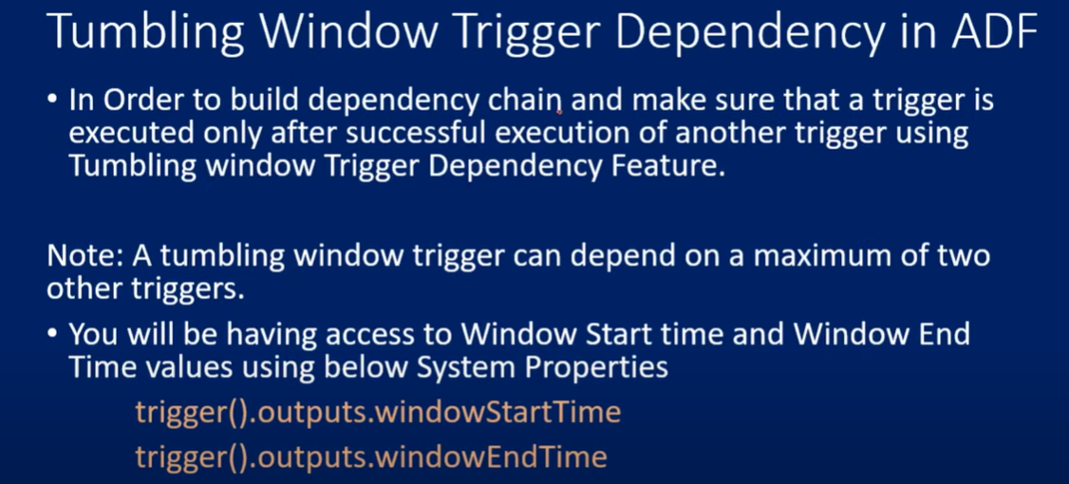

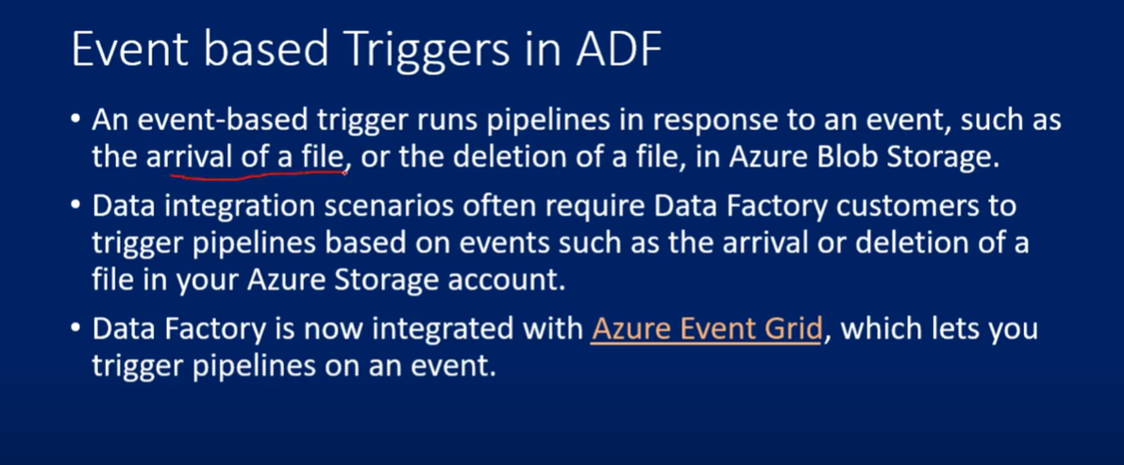

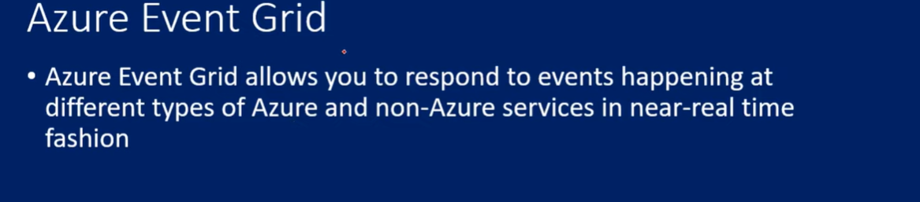

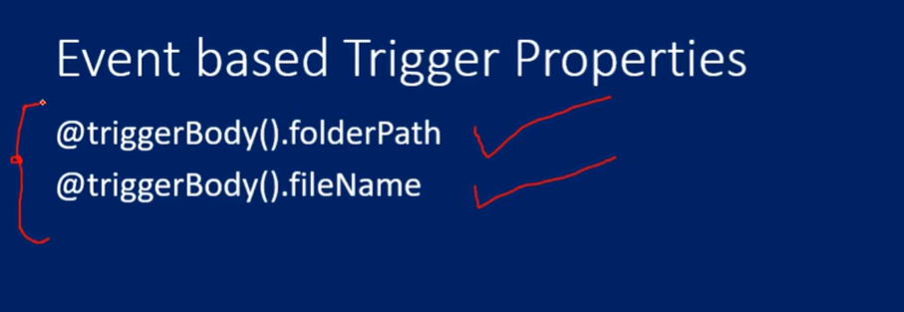

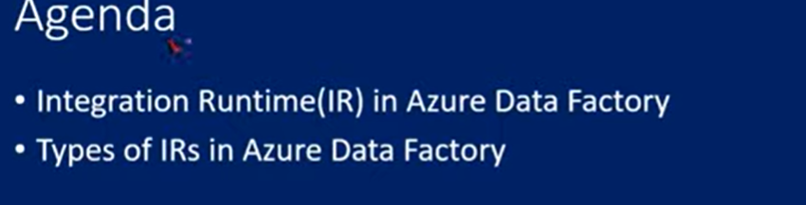

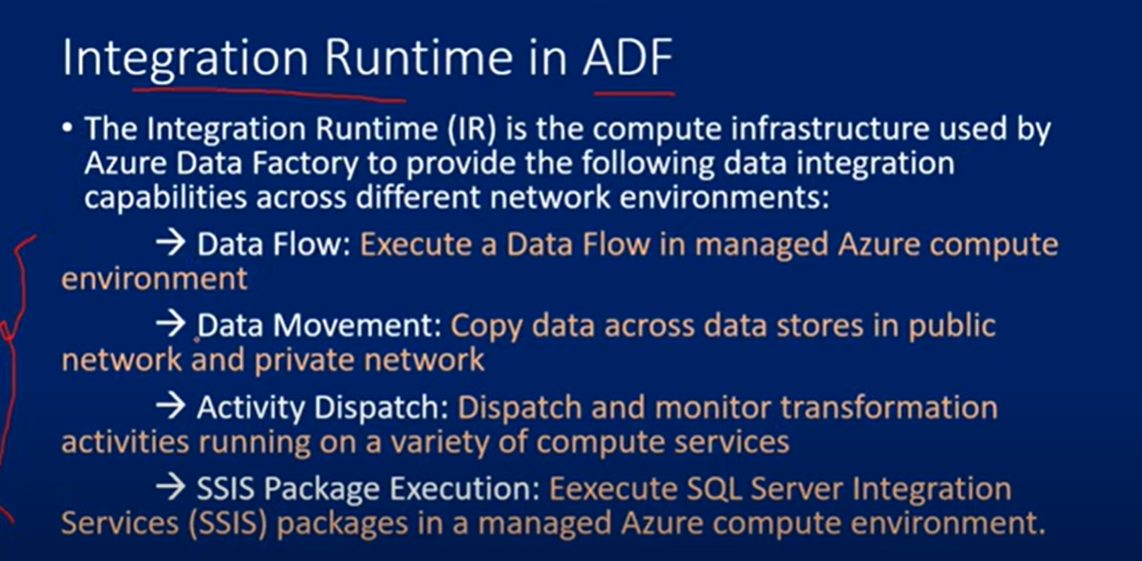 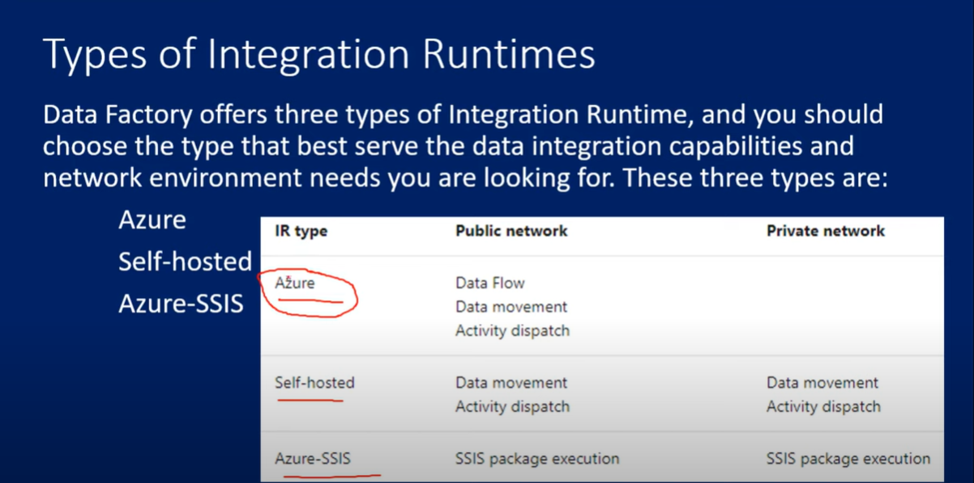 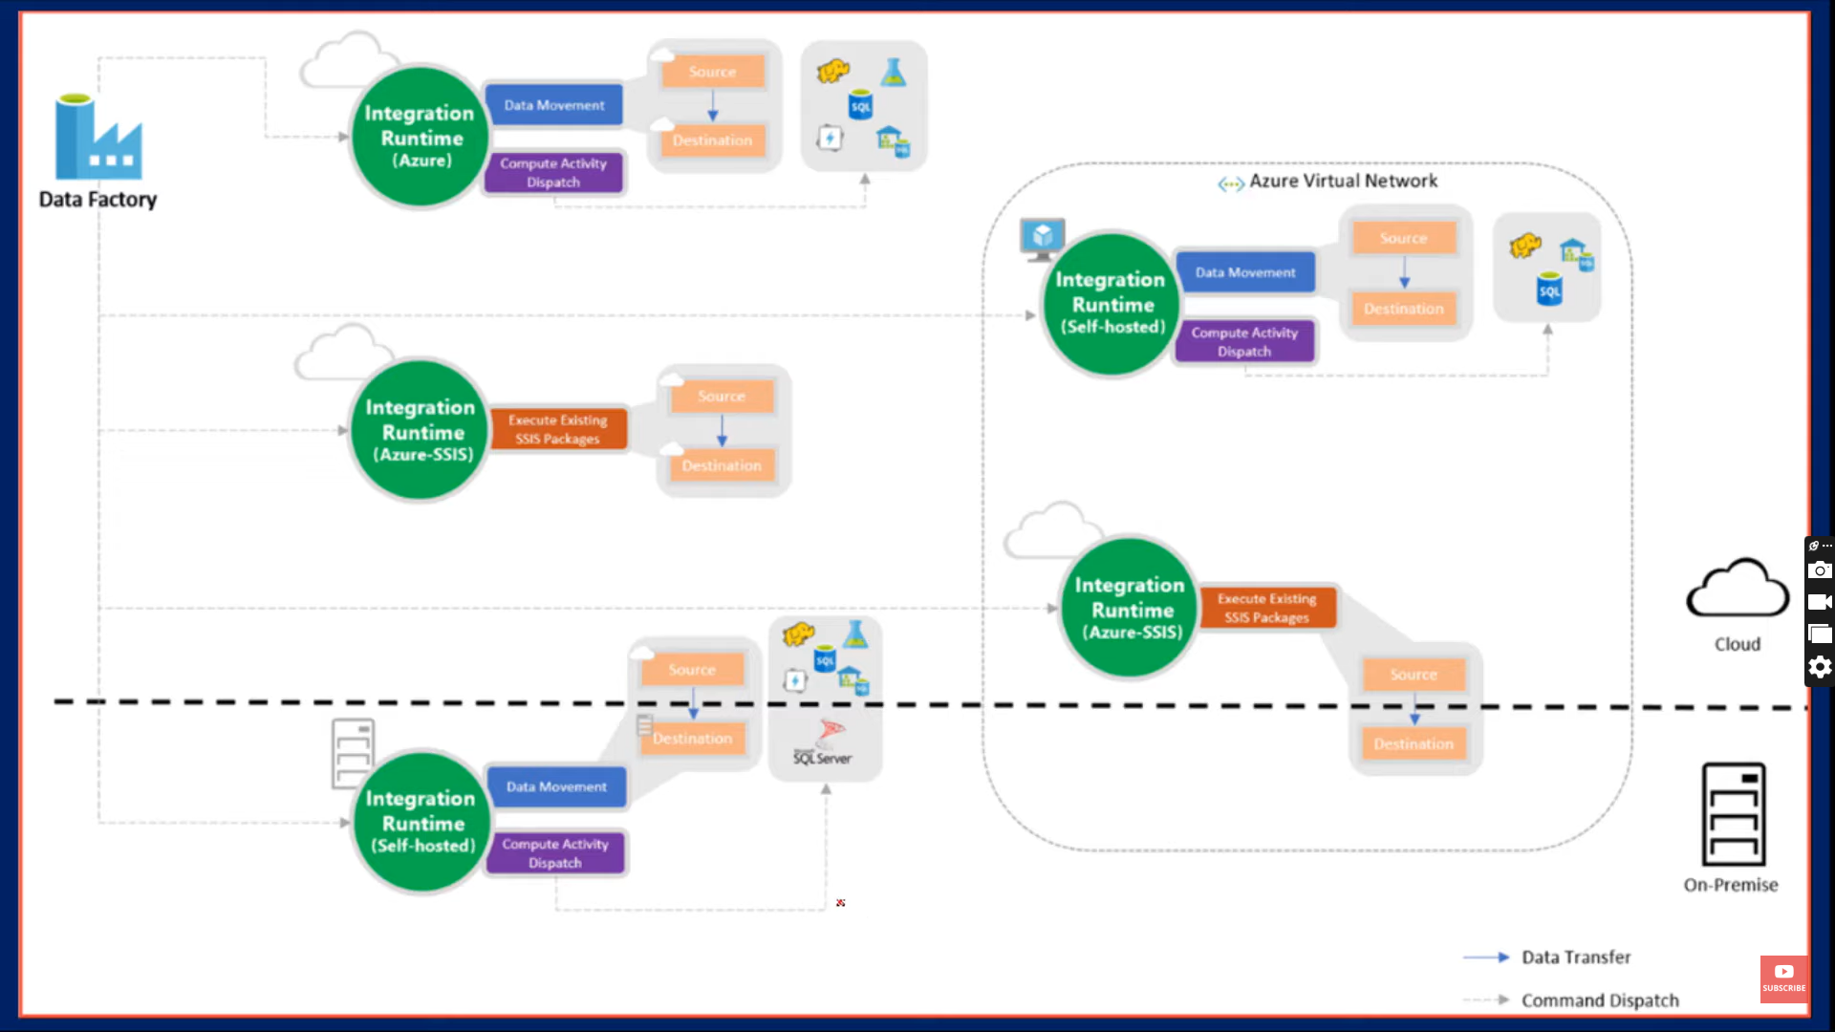

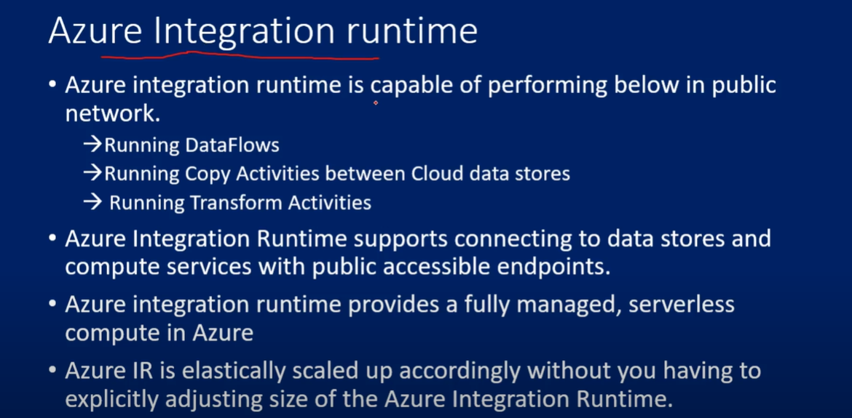

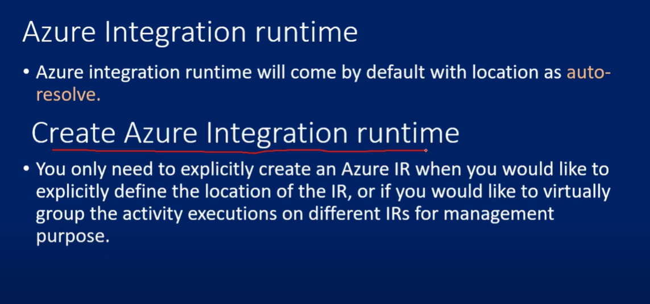

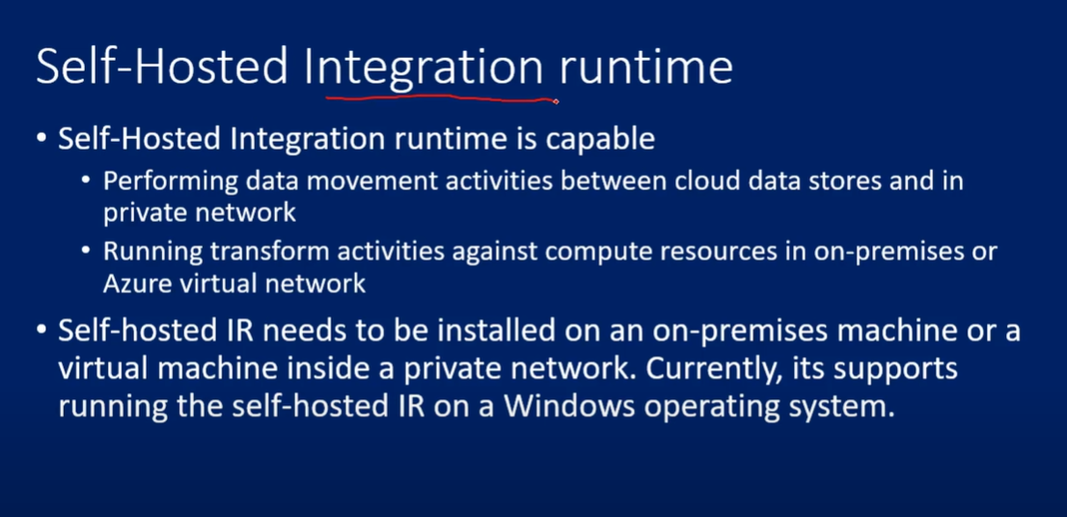

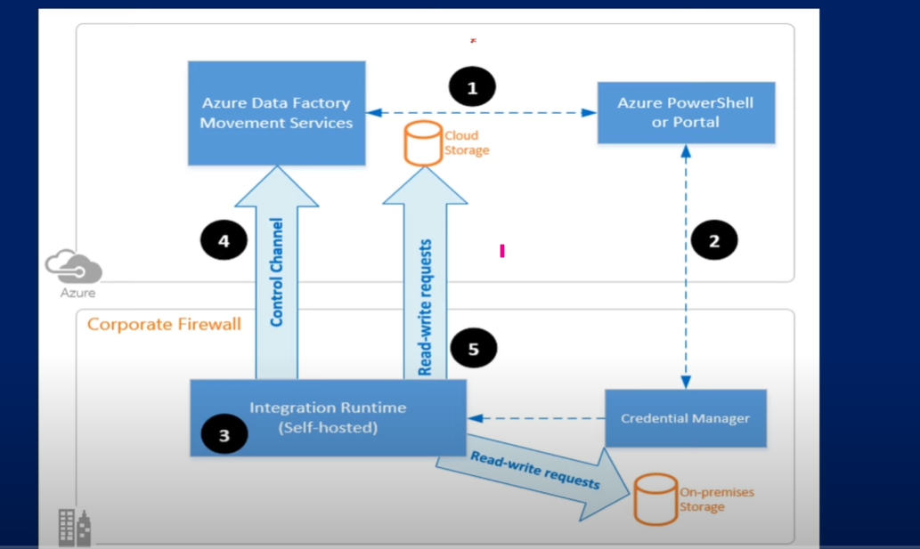

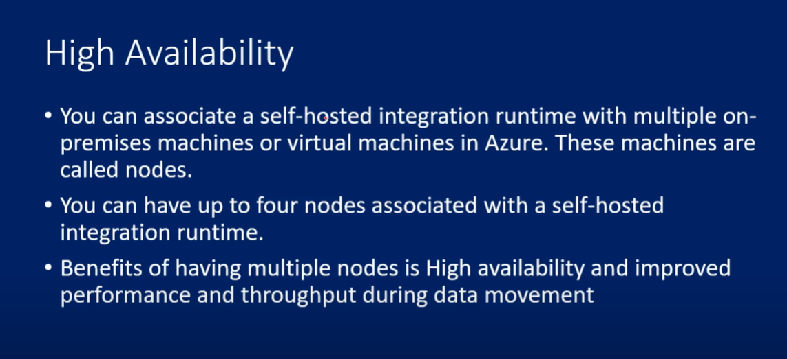

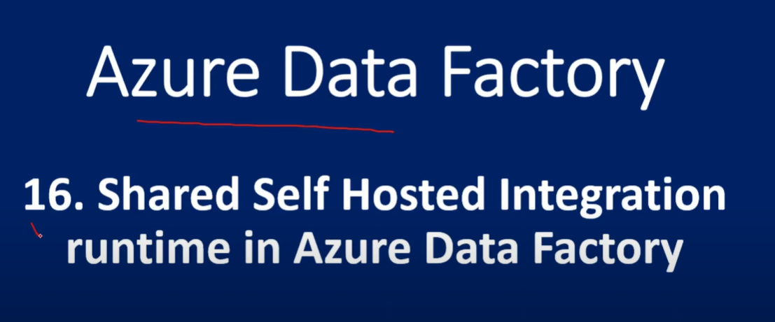

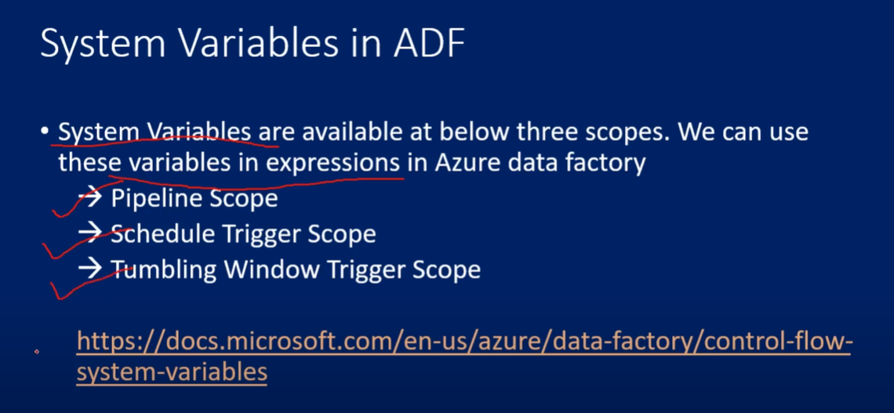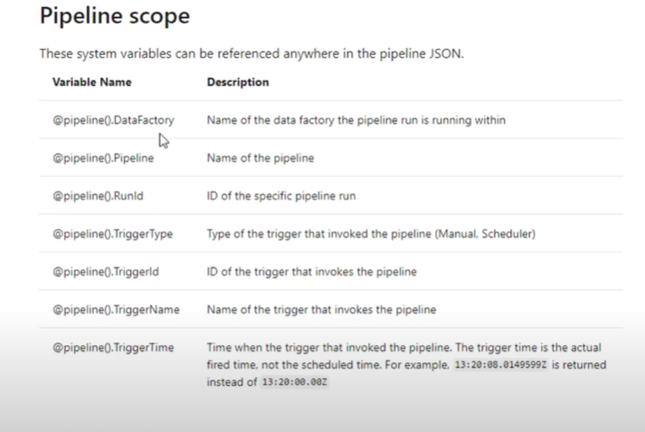

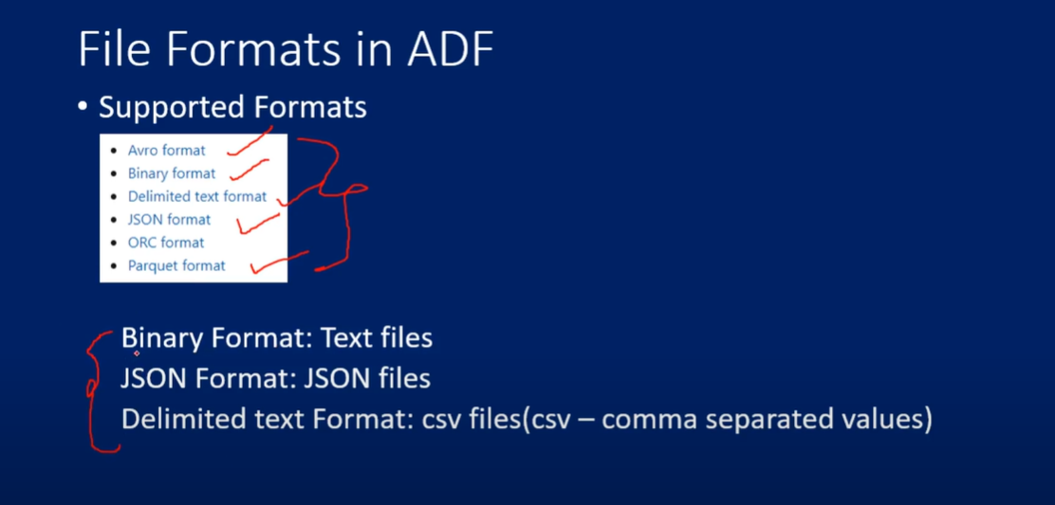

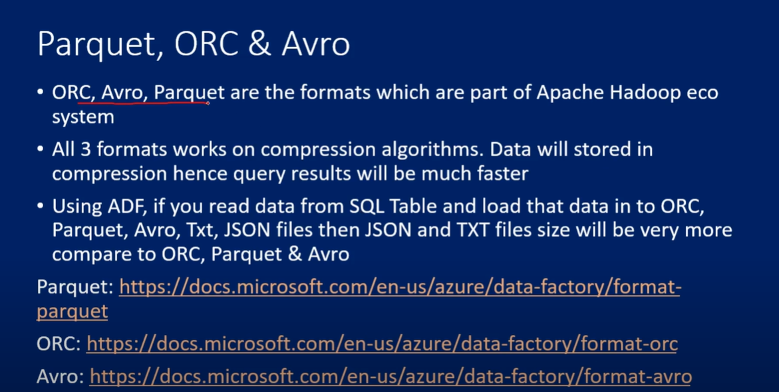

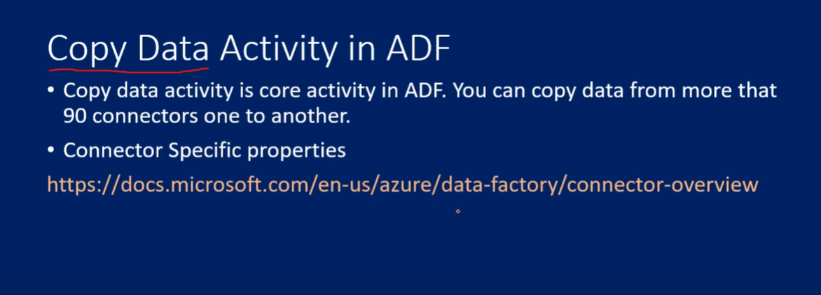

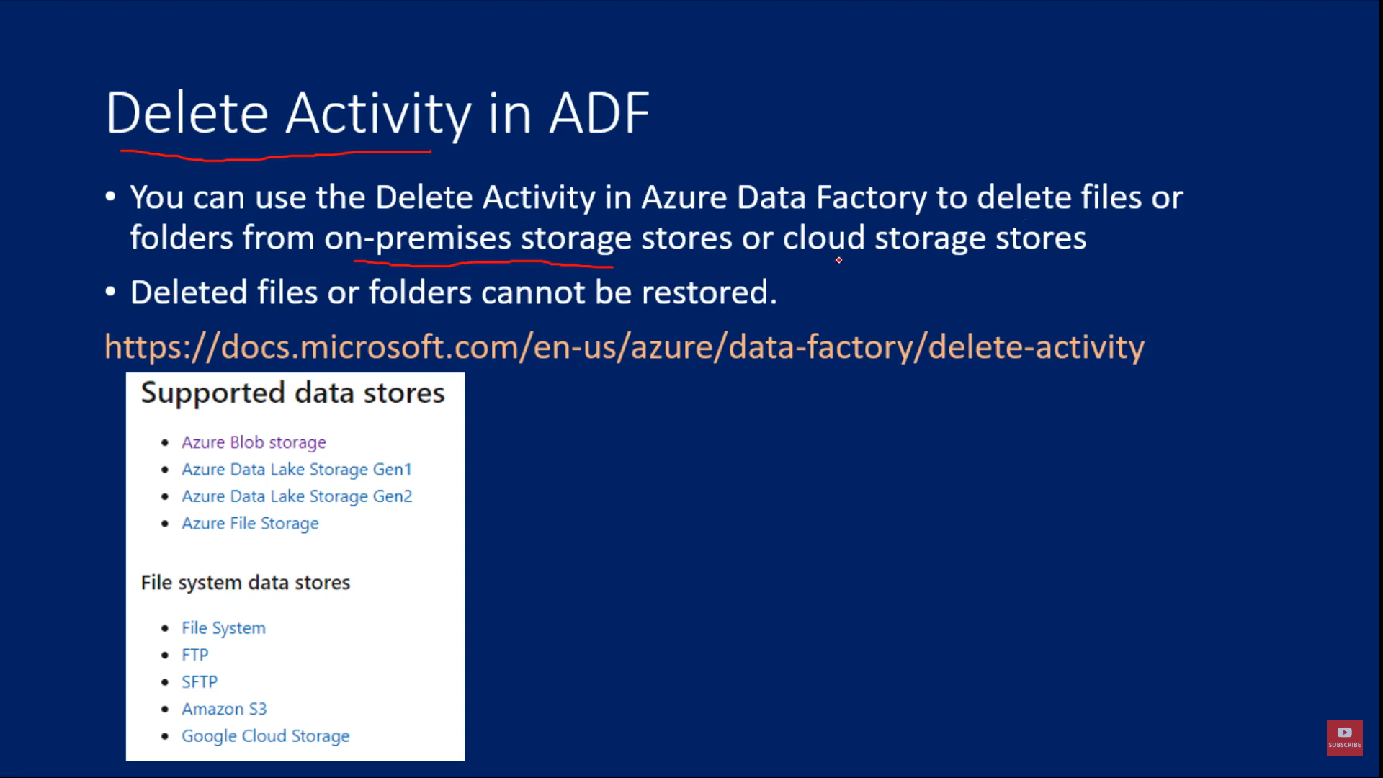

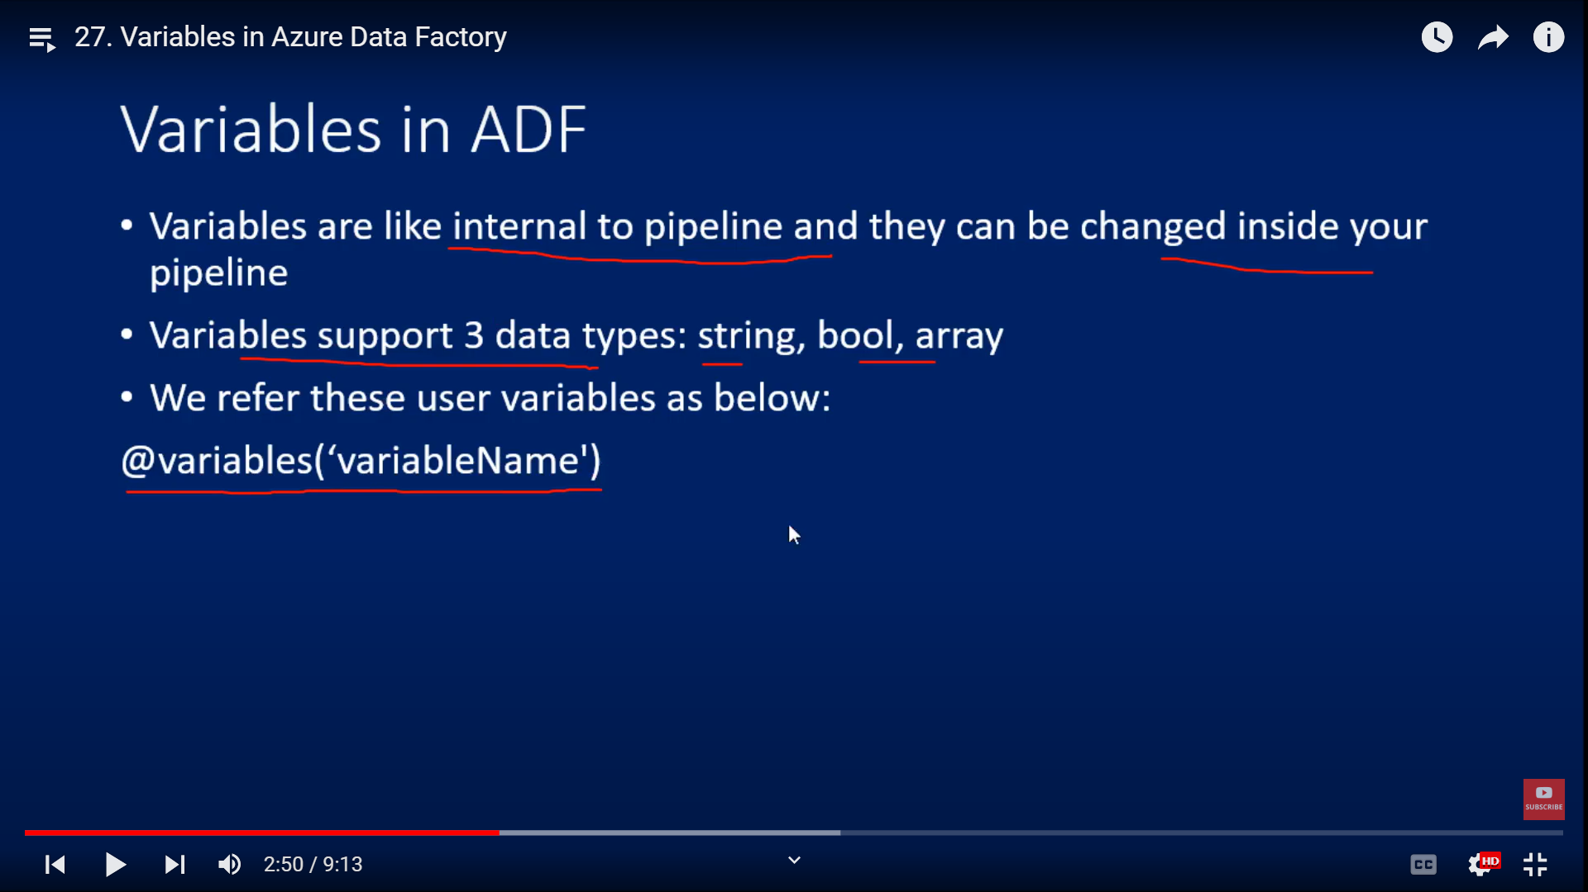

Parameters are external values passed into pipelines. They can’t be changed inside a pipeline. Variables, on the other hand, are internal values that live inside a pipeline. They can be changed inside that pipeline.

@variables(‘variablename’)

Event based trigger: @Triggerbody.filename

Filename = @Triggerbody.filename  
this parameter will hold filename  
from the variables  
Variable Name : Filetype  
value: @replace(pipeline().parameter.Filename,’Sales’,’’)  
- replacing HourlySales.csv filename to “Hourly.csv”

Put If condition  
true- copy to hours table  
false – copy to daily table

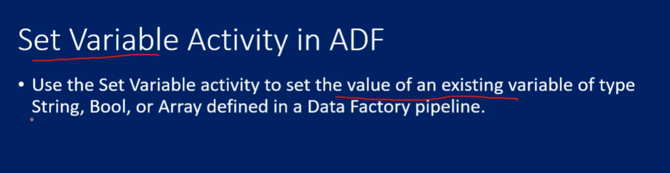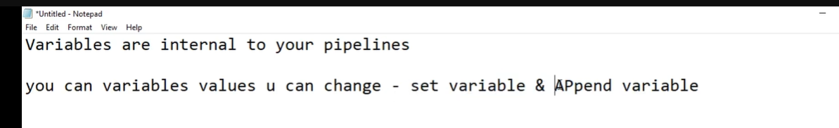

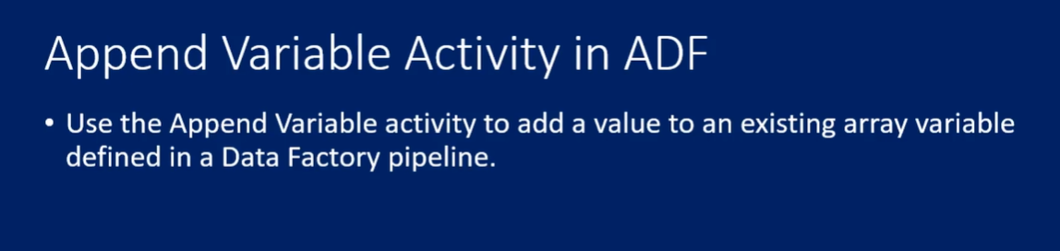

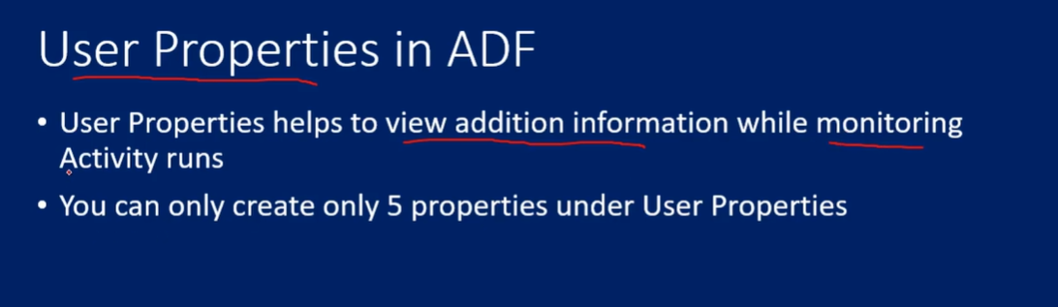

https://www.youtube.com/watch?v=nc4IFKkkfXM&list=PLMWaZteqtEaLTJffbbBzVOv9C0otal1FO&index=31

I have some Interview Questions I was asked. Please make some videos on the same as a request. 1. How to create a GENERIC pipeline that can be reused again? 2. Write a Single line query to delete data from 10 tables. 3. What is Encoding in COPY activity? 4. What is the limitation of LOOKUP activity? 5. How do you validate your SINK data in ADF whether it is right or wrong?

https://www.youtube.com/watch?v=WR6AbQ3grMU&list=PLMWaZteqtEaLacN3eS3s8pw2jtwBVb1BH